**PROJECT TITLE: AIR QUALITY MONITORING**

**NAME :** ANANTHAGURU.V

**REGNO : 953021106005**

**COLLEGE CODE : 9530**

**COLLEGE NAME :** ST.MOTHER THERESA ENGINEERING

COLLEGE

**NAN MUDHALVAN ID :**au953021106005

**TEAM NAME :** PROJ_201035_TEAM_1

**PROBLEM SOLUTION :**

Air pollution is one of environmental issues that cannot be ignored. Inhaling pollutants for a long time causes damages in human health. Traditional air quality monitoring methods, such as building air quality monitoring stations, are typically expensive. This project is suitable for air quality monitoring in real time.Design a tool which will sense quality of air and display it in the form of percentage,Sense how much carbon mono-oxide(CO) is present in air and display in the form of percentage,Sense the temperature and display it in degree celcius

**OVERVIEW OF PROJECT :**

This project provides a combination of process of sensing several gas levels in the air and also the ambient temperature and humidity, thus sensing the quality of the air.

The levels of the gases and the temperature is displayed in a LCD display panel , which continuously shows the real time output values of the gas sensors , temperature and humidity sensor.

**FLOWCHART :**

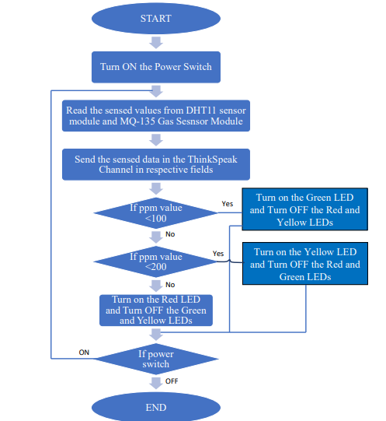

**COMPONENTS :**

Arudino UNO Board

16x2 LCD Display

MQ135 Gas Sensor

DTH11 Temperature Sensor

10K Potentiometer

Breadboard

**PROCEDURE :**

NodeMCU plays the main controlling role in this project. It has been programmed in a manner, such that, it senses the sensory signals from the sensors and shows the quality level via led indicators. The DHT11 sensor module is used to measure the temperature and the humidity of the surroundings.With the help of the MQ-135 gas sensor module, air quality is measured in ppm. These data are fed to the ThinkSpeak cloud over the internet. We have also provided LED indicators to indicate the safety levels.

STEP 1. Firstly, the calibration ofthe MQ-135 gas sensor module is done. The sensor is set to preheat for 24 minutes. Then the software code is uploaded to the NodeMCU followed by the hardware circuit to calibrate the sensor has been performed.

STEP 2. Then, the DHT11 sensor is set to preheat for 10 minutes.

STEP 3. The result of calibration found in STEP 1 is used to configure the final working code.

STEP 4. The final working code is then uploaded to the NodeMCU.

STEP 5. Finally, the complete hardware circuit is implemented. The software codes and the hardware circuits are described in the following chapters

SOFTWARE :

* ARDUINO

Arduino is an open-source electronics platform based on easy-to-use hardware and software. Arduino boards are able to read inputs - light on a sensor, a finger on a button, or a Twitter message - and turn it into an output - activating a motor, turning on an LED, publishing something online.